Model Exam
MLA0214 – Fundamentals of Machine Learning for Motlbot
Name: Siva Dakshitha Reg no:192425395

Experiment-3(KNN)

Aim
To classify emails using nearest neighbors.
Algorithm
- Encode data
- Choose K (e.g., 3)
- Calculate Euclidean distance
- Select nearest neighbors
- Majority voting

Code

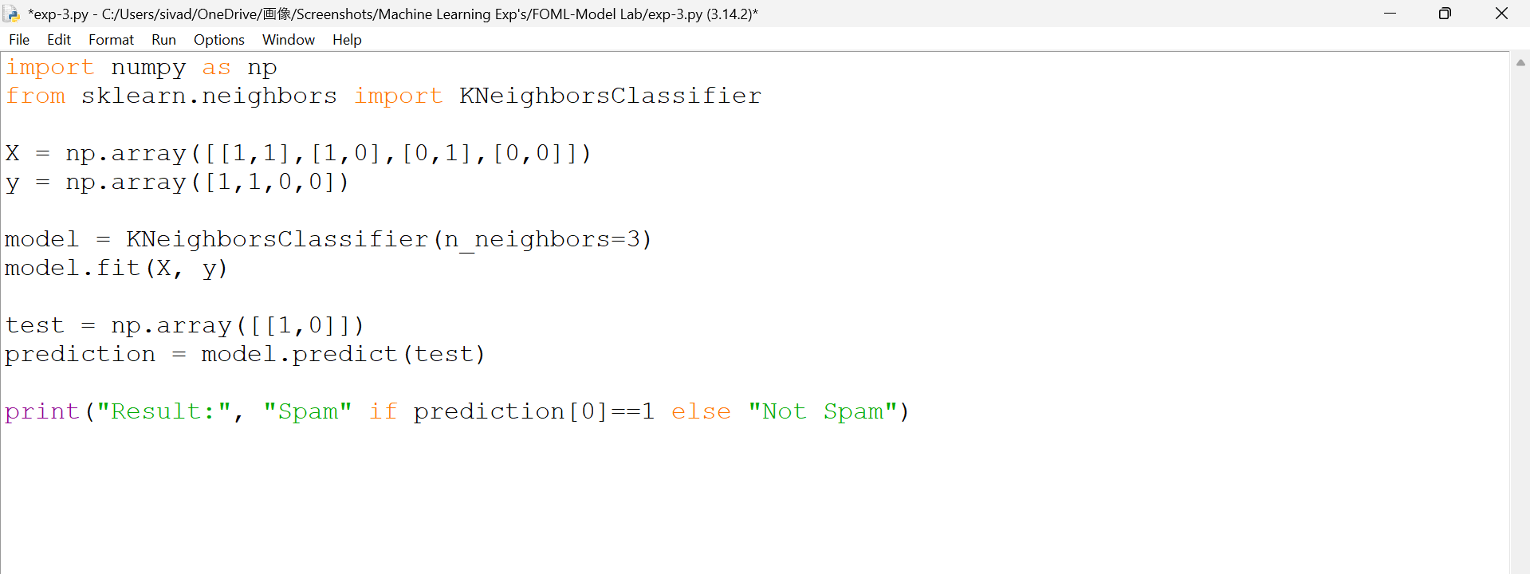

Output

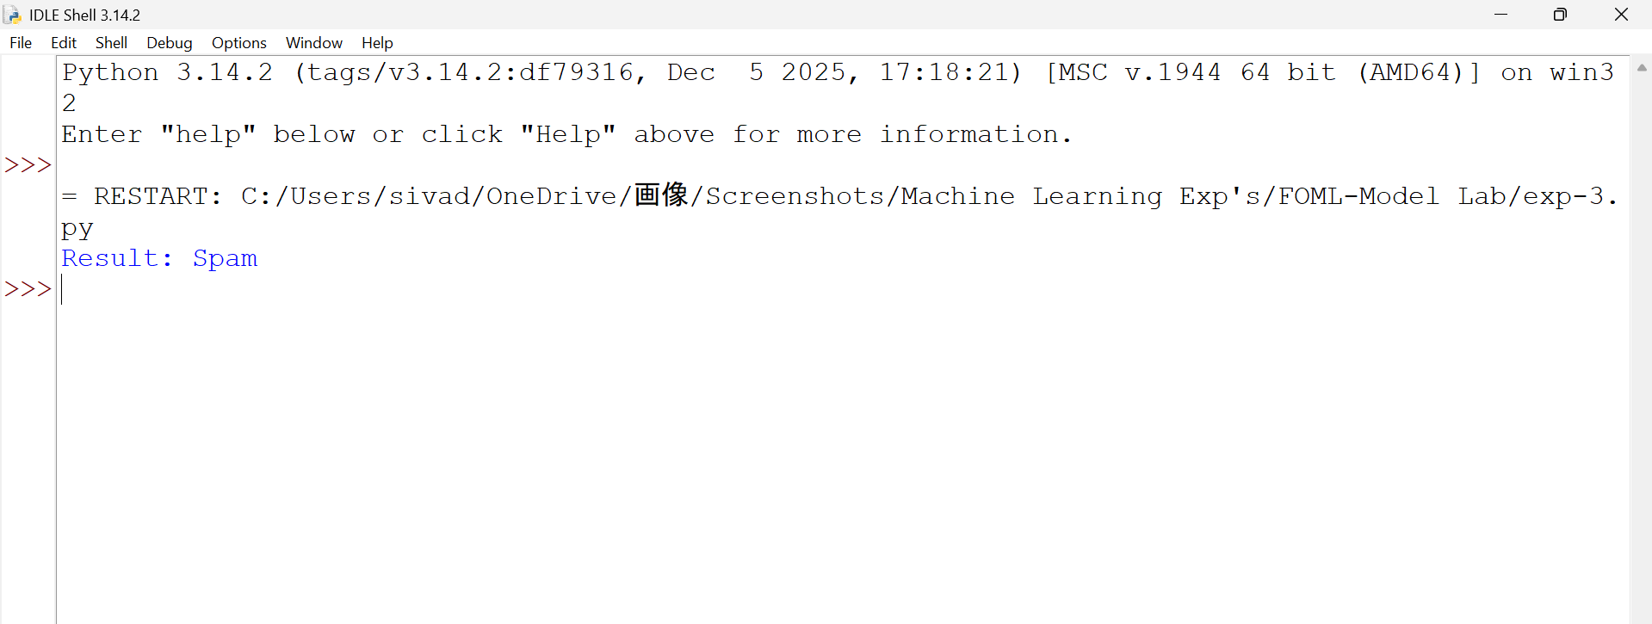

Result
K-Nearest Neighbors (KNN) algorithm was successfully implemented and the spam email classification was performed successfully.

